SC2107 Lab2 Assignment Sheet (to be submitted to NTULearn before next lab)

Name: SARAVANAKALEESWARAN ARUN KARTHICK Lab Group: SCEC Date: 11/09/24

1. **Section 6.2. Give a short 2-3 lines description on concept behind the reflectance reading process. Why does the black surface result in slower voltage decay?**

**Answer Q1 Section 6.2:** The reflectance sensors determine the position of the robot based on the amount of IR wave reflected back. Black surfaces are good at absorbing IR waves, thus reflecting lesser IR wave to the base of the transistor. The reflectance of the surface affects the effective resistance of the transistor which in turn affects the decay rate of the voltage at the pins. As a result, less current flows through the collector- emitter thereby reducing the voltage decay rate.

1. **Section 6.2. Which parameter do you need to tweak in the Reflectance_Read() if the reflectance sensor reading is not accurate? Hint: check the 8 steps for Reflectance reading.**

**Answer Q2 Section 6.2:** If the sensor reading is inaccurate, we should tweak the “Clock_Delay1us” parameter in the Reflactance_Read(). By modifying the duration the system waits for the capacitor to discharge before reading the sensor values, we can improve the accuracy by either increasing/decreasing the waiting time. This timing varies depending on the reflectivity of different types surface.

1. **Section 6.2. Write down the procedure to initialise P7.3 to be an input pin without internal pull-up resistor**

**Answer Q3 Section 6.2:**

Step 1: Set GPIO:

P7->SEL0 = 0x00;

P7->SEL1 = 0x00;

Step 2: Set input:

P7->DIR &= ~0x08;

Step 3: Disable pull up   
P7REN &= ~0x08;

1. **Section 6.3. Where are the sources of the offset error between actual distance and the estimated distance return by the function Reflectance_Position()?**

**Answer Q4 Section 6.3:** Some of the reasons for the offset error between the actual distance and the estimated distance may be:

Calibration error: Issues within the sensors like sensor calibration may lead to inaccurate readings

Environmental factors: Variation in ambient light, surface and etc could affect the amount of light being reflected which can cause a change in the values.

1. **Section 7.2.  Figure 7. The robot state toggled between LEFT and CENTER state repeatedly when it is detected that the robot is off to the left of the line (input: ‘01’). If the outputs of the FSM states are connect to the input of the DC motor, how would the input signals to the DC motor looks like? Which wheel will move at a slower speed?**

**Answer Q5 Section 7.2:** The input (0, 1) refers to the signals from the center two reflectance sensors, 0 indicating that the left sensor does not detect the line and 1 indicating that the right sensor detects line, meaning that the robot is off to the left of the line. Based on Figure 7, this input toggles between the “LEFT” and “CENTER states repeatedly. *Toggling between the input signals to the DC motor which are “LEFT” state (500, 1, 0) and “CENTER” state (500,1,1) means that the left wheel spins faster and the right wheel spins at a slower speed*

1. Section 7.3. Fix the bug in the 11-state FSM design.  
   A picture containing table

   Description automatically generated

**Answer Q6 Section 7.2:** As circled in red below, the bugs are the at the Left_stop’s and Right_stop’s input “11” where it should have been Left_stop and Right_stop respectively instead of Center.

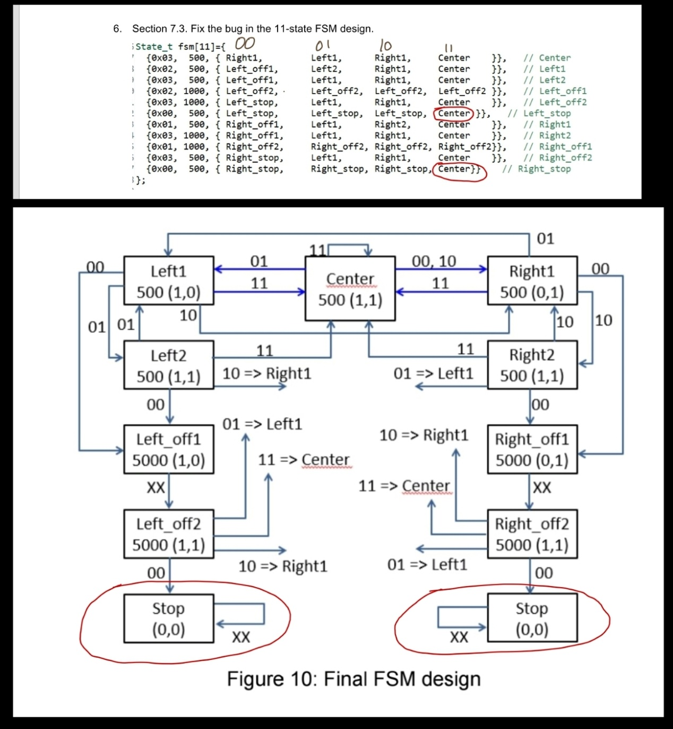

1. **Section 7.3. What is the purpose of toggling LED within the main routine or ISR?**

**Answer Q7 Section 7.3:** By toggling the LEDs, we get to know what state the robot is in and by the color of the LEDs, we can determine the position (LEFT, RIGHT, CENTRE, etc) as well. This further helps us to determine the course of action, whether to turn or stop or go straight.

1. **Section 7.4. What hardware and software modifications are required in order for the robot to move within a lane, i.e. between two black lines, instead of following a line? Detail algorithm not required. Just one bullet point each for hardware and software.**

**Answer Q8 Section 7.4**

**Hardware:** We can add additional sensors so that the robot is able to take accurate inputs from the left and one on the right line

**Software:** Adjust the algorithm to be able to analyze the position of the robot based on two sensor inputs in such a way that we have the position of the robot in respective of both the lines and also change the movement strategy of the robot to be able to stay in the center of the lane( 2 black lines)